Chapter 19, Solution 72.

Consider the network shown below.
I₁
I₂
+
V_{a2}
−
+

V₂

−
I_{a2}
+
V_{b2}
−
I_{b2}
+
V_{a1}
−
I_{a1}
+
V_{b1}
−
I_{b1}
N_{a}
N_{b}
+

V₁

−
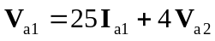 (1)
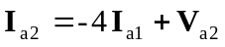 (2)
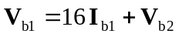 (3)
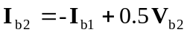 (4)

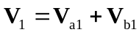
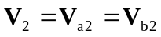
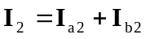
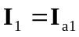

Now, rewrite (1) to (4) in terms of 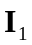 and 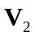
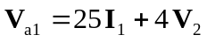 (5)
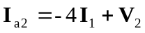 (6)
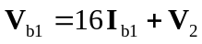 (7)
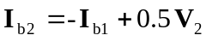 (8)

Adding (5) and (7),
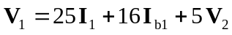 (9)

Adding (6) and (8),
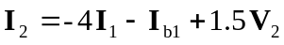 (10)

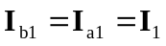 (11)

Because the two networks 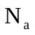 and 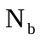 are independent,
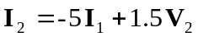
or 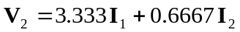 (12)

Substituting (11) and (12) into (9),
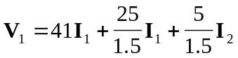
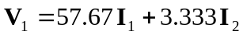 (13)

Comparing (12) and (13) with the following equations
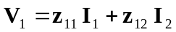
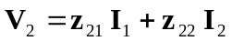
indicates that
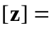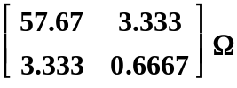

Alternatively,
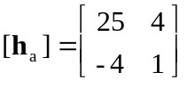, 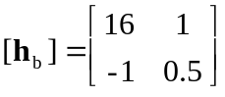

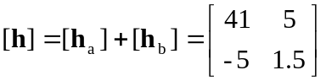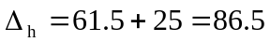

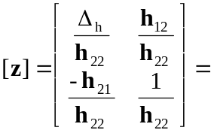
as obtained previously.

